AI Assisted Coding
Assignment Number:1.3
Name:MD.ADIL
HtNo:2303A51988
BtNo:05
Lab 1: Environment Setup – GitHub Copilot and VS Code Integration + Understanding AI-assisted Coding Workflow
Task 0:
● Install and configure GitHub Copilot in VS Code. Take screenshots of each step. 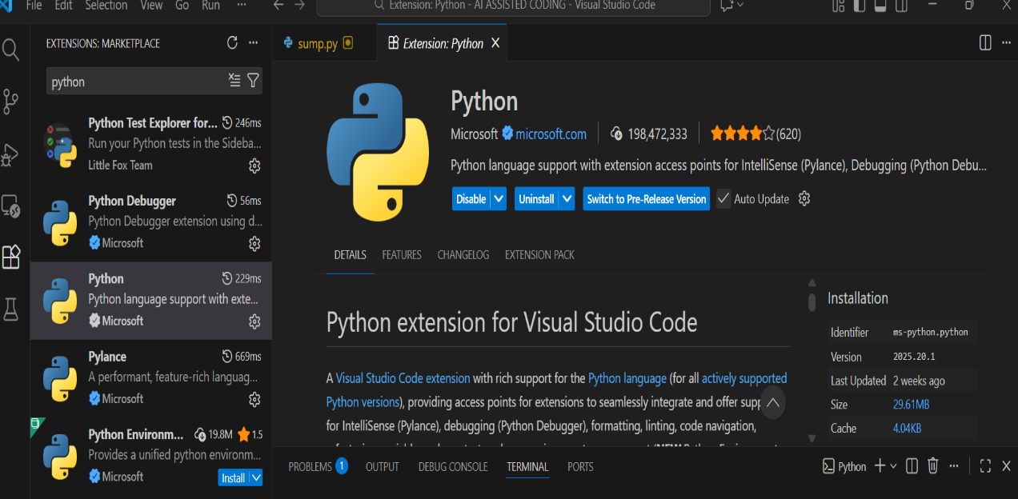
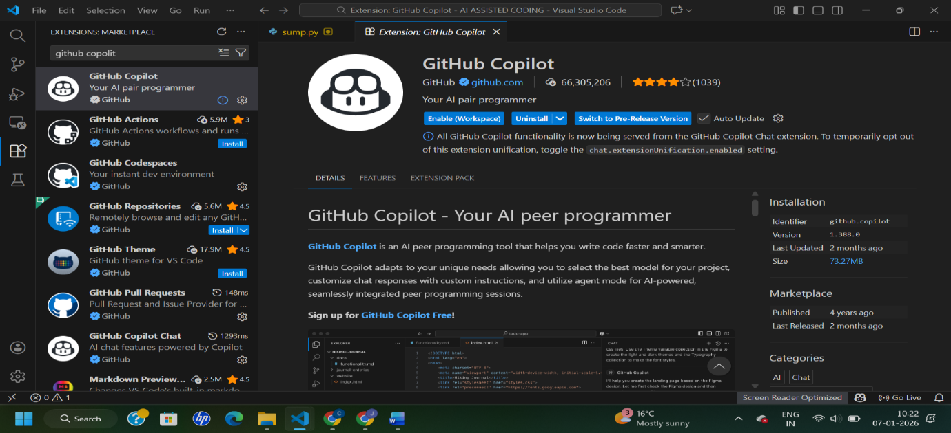
Task 1: AI-Generated Logic Without Modularization (Fibonacci Sequence Without Functions)
Step-1:prompt
Create a simple python program that prints the Fibonacci series up to n terms. Do not use any functions. Take n as input from the user using Scanner and print the Fibonacci numbers in one single line with spaces between them.
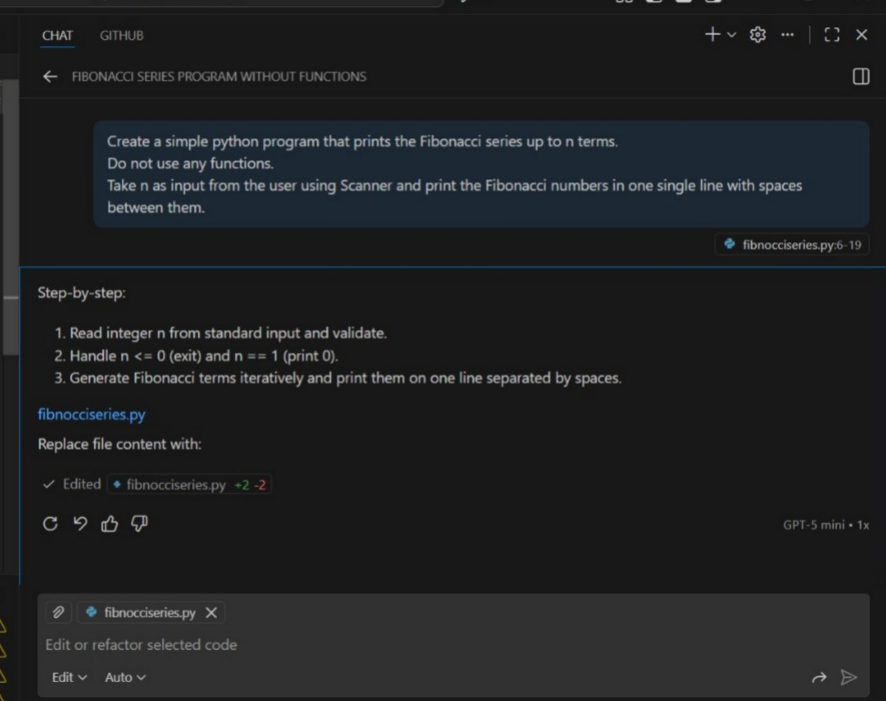
Step-2:Code
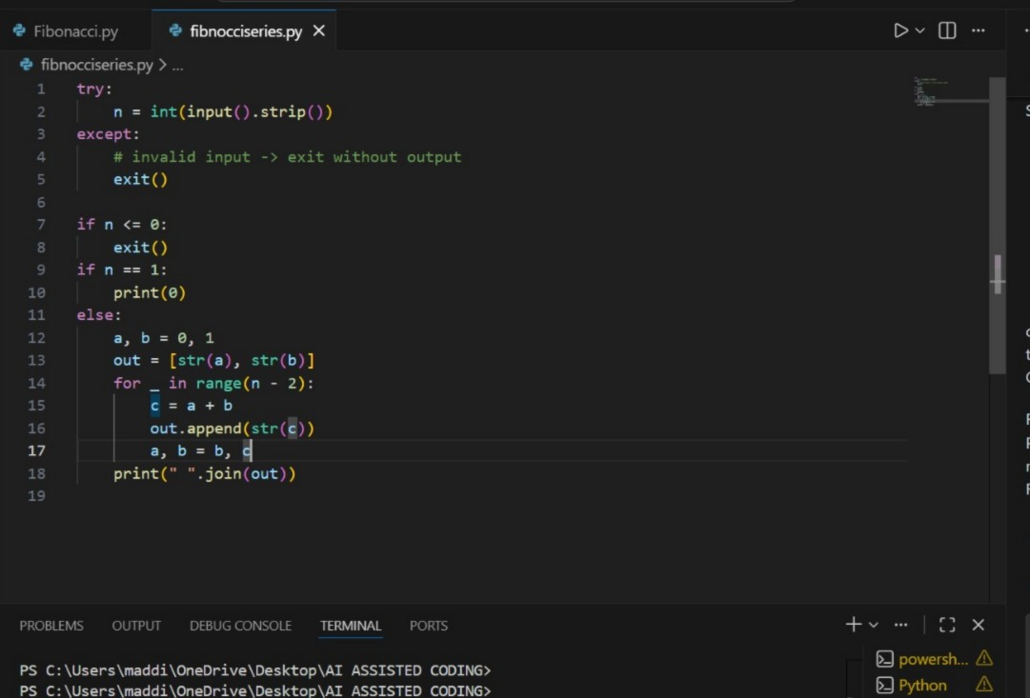
Step-3:Output
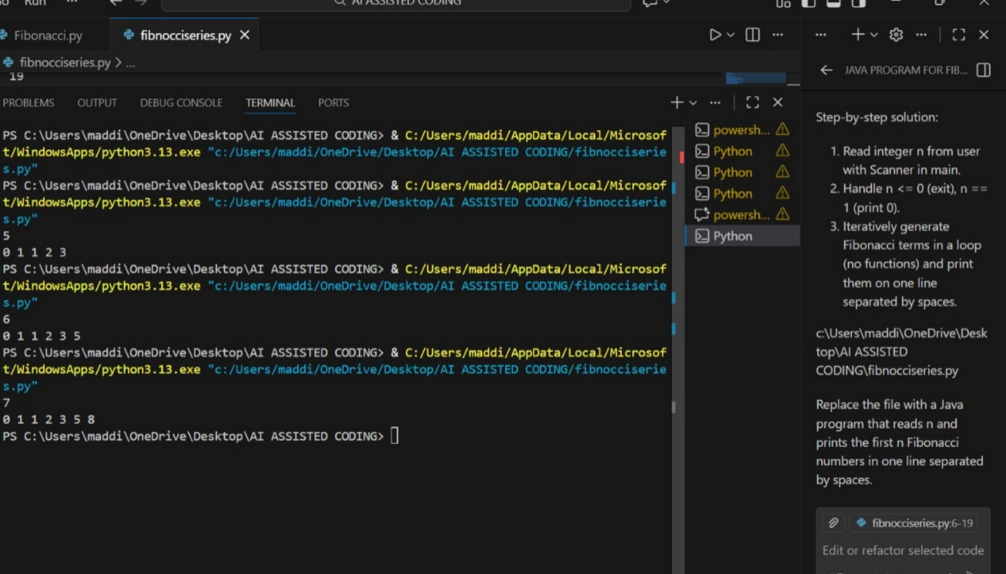
Step-4:Explanation
- The program takes n as input using Scanner.
- Two variables a = 0 and b = 1 store the first two Fibonacci numbers.
- It prints a first because Fibonacci always starts with 0.
- A loop runs from 1 to n-1 to generate the remaining terms.
- In each loop, next = a + b calculates the new number.
- The program prints b and then next in the next iterations.
- After printing, it updates a = b and b = next for the next calculation.
- Finally, the Fibonacci series prints in one single line with spaces.

Task 2: AI Code Optimization & Cleanup (Improving Efficiency)
Step-1:Prompt
Create a simple python program that prints the Fibonacci series up to n terms with using functions. Take n as input from the user using Scanner and print the Fibonacci numbers in one single line with spaces between them.

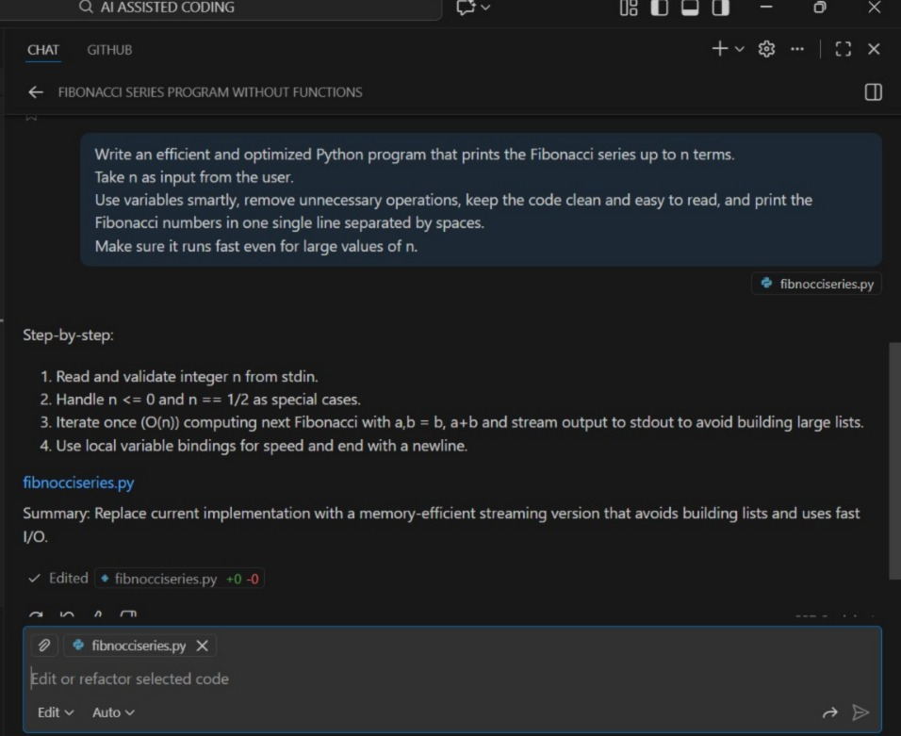
Step-2:code
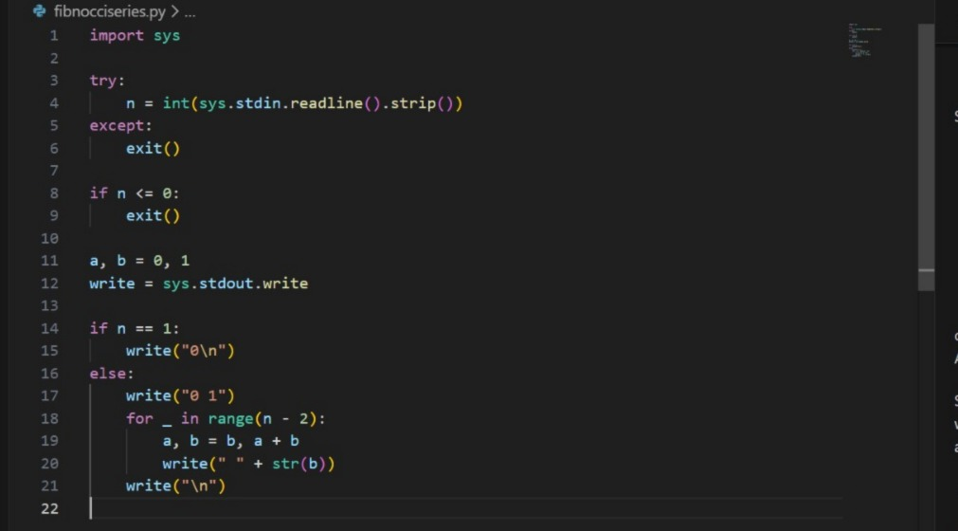
Step-3:Output
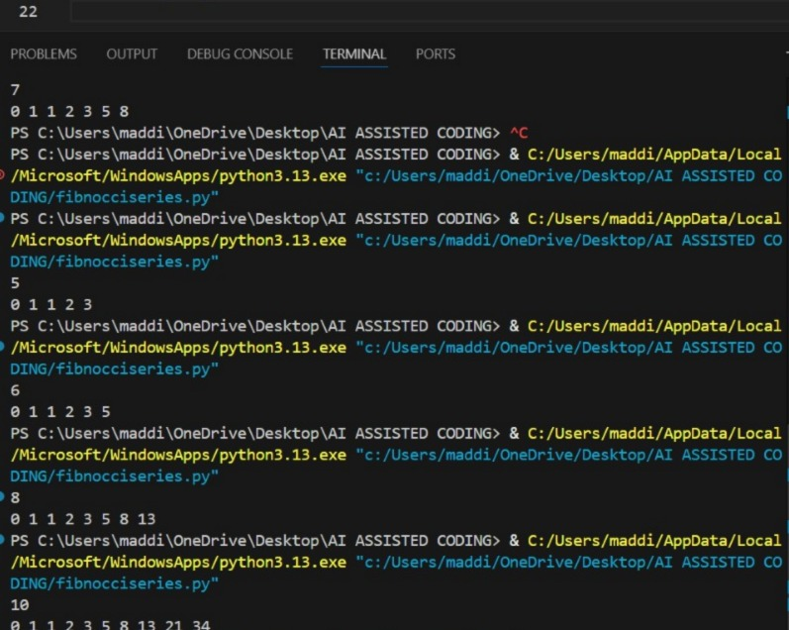
Step-4:Explanation
- The program reads the number n from the user.
- It sets two variables to start the sequence: a = 0 and b = 1.
- A loop runs n times to generate Fibonacci numbers one by one.
- In every iteration, it prints the current value of a.
- The next number is calculated efficiently by swapping values instead of extra temp variables.
- b always becomes the sum of the previous two numbers.
- No function calls are used, so the program runs faster and stays simple.
- The final output prints all Fibonacci numbers in one line with spaces, even for large n.
Task 3: Modular Design Using AI Assistance (Fibonacci Using Functions)
Step-1:prompt
Write a modular Python program that generates the Fibonacci series up to n terms using functions. Take n as input from the user.Use a separate function to compute the Fibonacci sequence efficiently and return the result. Print the output in one line with spaces between the numbers.
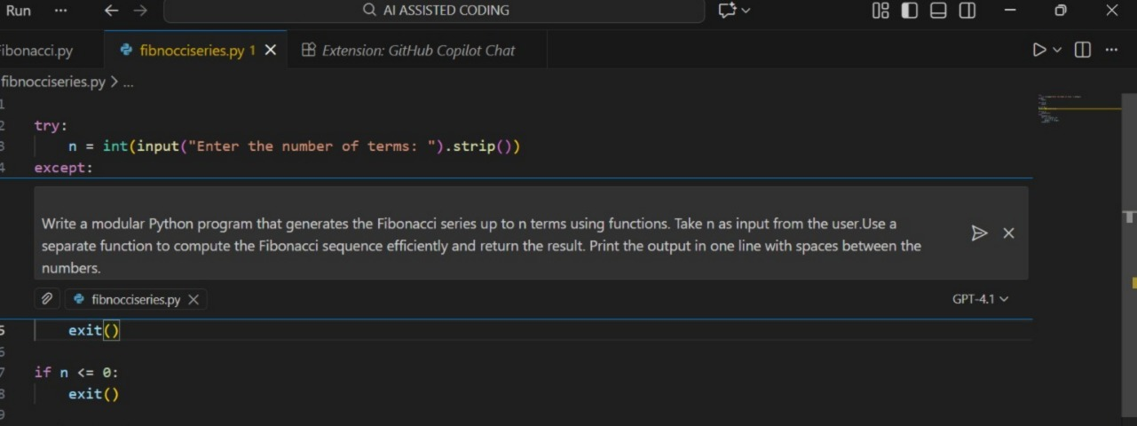
Step-2:Code
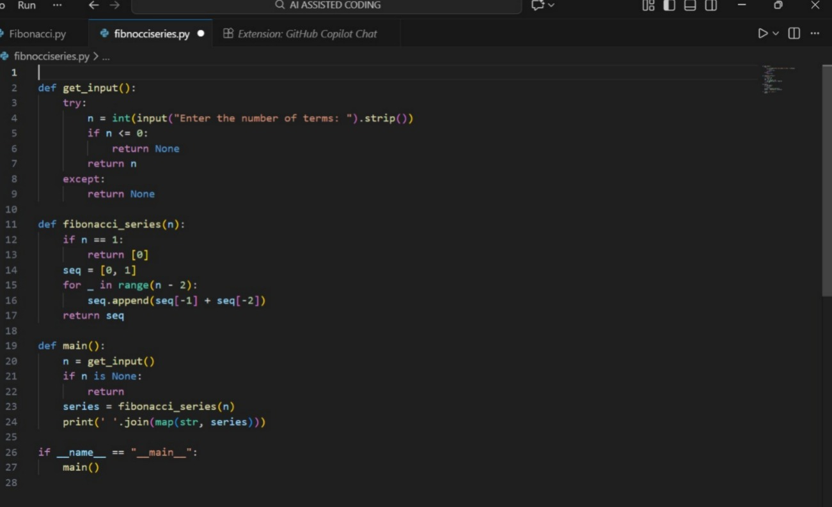
Step-03:Output
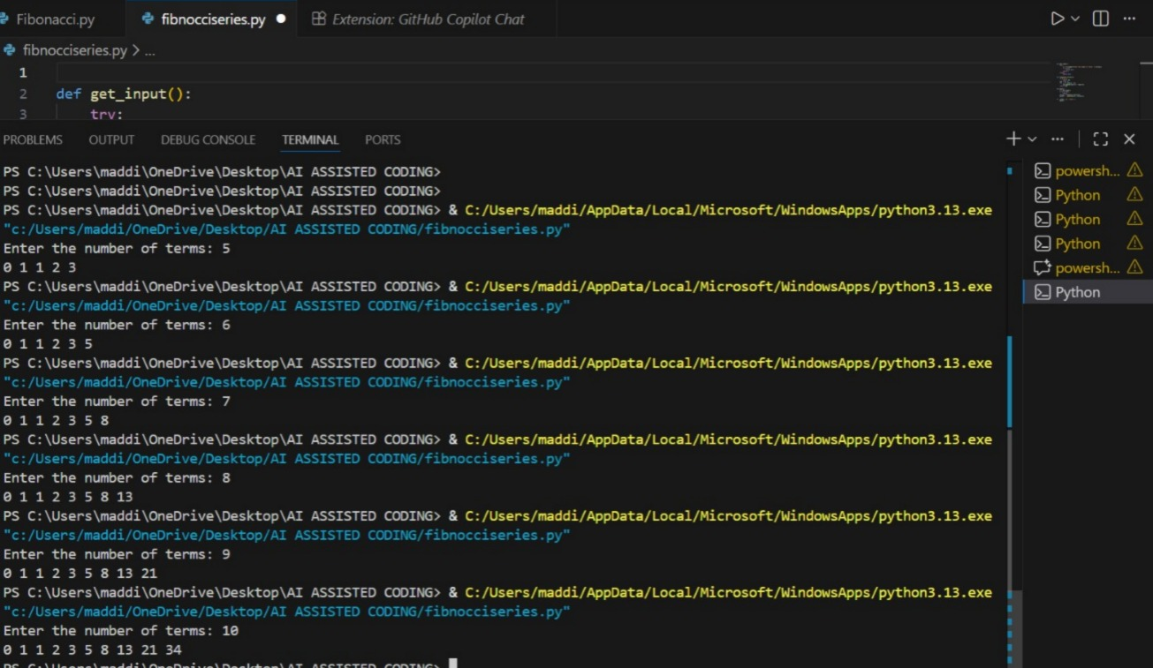
Step-04:Explanation
- The program asks the user to enter a number n.
- A function is created to generate Fibonacci numbers instead of writing everything in one place.
- Inside the function, the series starts with 0 and 1.
- A loop calculates the next numbers by adding the previous two.
- All the Fibonacci numbers are stored in a list and returned by the function.
- The main part of the program calls the function and gets the list.
- Then it prints the numbers in one single line with spaces between them.
- Using functions makes the code clean, reusable, and easier to improve later.

Task 4: Comparative Analysis – Procedural vs Modular Fibonacci Code.
Feature | Without Functions | With Functions
Code Clarity |  | Logic is separated into a named function → easier to understand
  Logic is written in one block; harder to read when long
Reusability | Cannot reuse Fibonacci logic without rewriting | Can call the function anywhere in program
Debugging Ease | Bugs must be traced in main logic, mixed with other code | Errors isolated in function → easier to test & fix
Suitability for Larger Systems | Poor; not scalable, becomes messy with added features | Good; fits into bigger systems, easier to maintain
Testing | Hard to unit test a part of code independently | Function can be tested separately with multiple inputs
Maintainability |  | High; changes only in function, no impact on main flow
  Low; changes affect entire code block
Performance Impact | No function call overhead (very small benefit) | Minimal overhead but worth it for structure & scaling
Task 5: AI-Generated Iterative vs Recursive Fibonacci Approaches (Different Algorithmic Approaches for Fibonacci Series)
Step-01:Prompt
Generate iterative and recursive Fibonacci code in Python. Take user input n. Keep code clean and optimized. Add explanation on efficiency.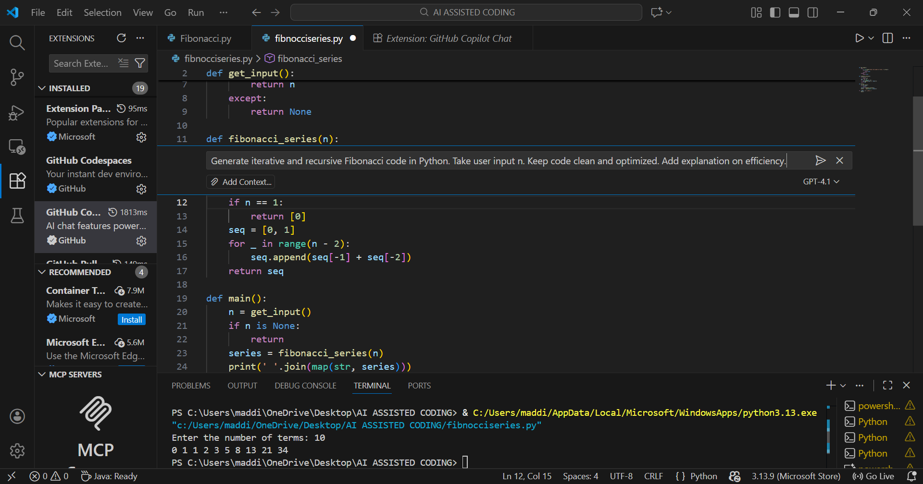
Step-02:Code
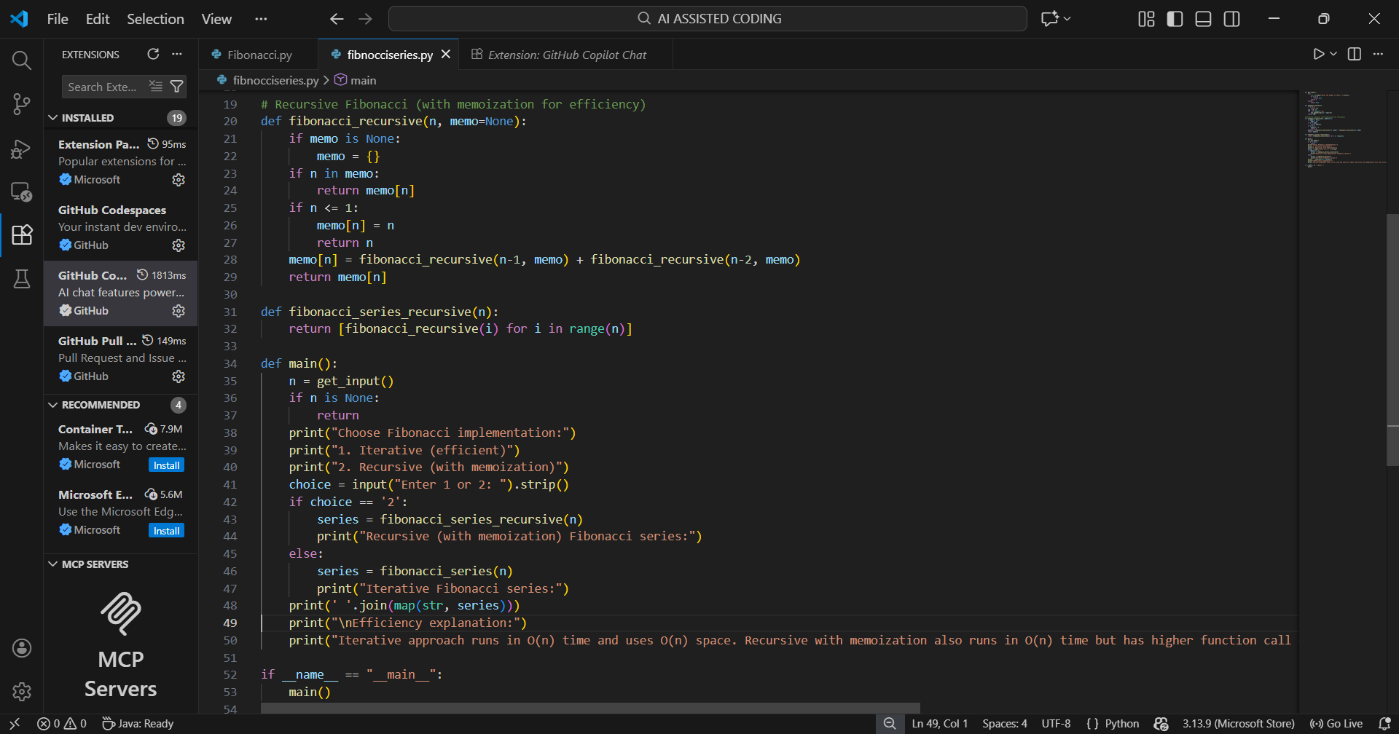
Step-03:Output
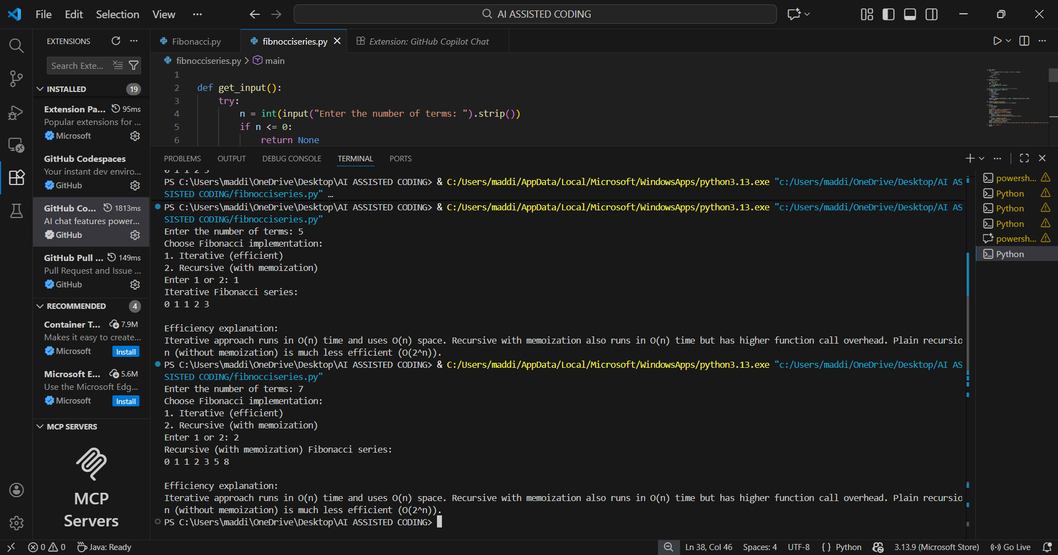
Step-04:Explanation
Iterative Approach
- The program takes n from the user.
- It starts Fibonacci with two variables: a = 0, b = 1.
- A loop runs n times to create the sequence step by step.
- In each round, it prints a, then updates the values (a becomes b, b becomes a + b).
- This method is fast, uses very little memory, and works well even for big n.
Efficiency:
- Time: O(n) → runs in a straight line with loop
- Space: O(1) → only 2 variables used

Recursive Approach
- The program takes n from the user.
- A recursive function calls itself to find Fibonacci numbers.
- It breaks the problem into smaller parts: fib(n) = fib(n-1) + fib(n-2).
- It keeps calling itself until it reaches the base values (0 and 1).
- This method is slow for large n because it repeats the same work many times.
Efficiency:
- Time: O(2ⁿ) → grows very fast, not good for big n
- Space: O(n) → stack memory is used for every call

Comparison:
Aspect | Iterative
  Recursive
Time Complexity | O(n) | O(2ⁿ) (very slow due to repeated calls)
Space Complexity | O(1) | O(n) (stack memory for calls)
Performance for Large n | Excellent (can handle 10⁷+ if needed) | Poor (fib(50) may take seconds/minutes)
Memory Usage | Very low | High because of recursion stack
Scalability | Best for real systems | Not scalable without optimization
Risk | No crash risk
  StackOverflow for large n

